Light-induced phenomena in condensed matter system from ab initio approach

Dongbin Shin

Department of Physics and Photon Science, Gwangju Institute of Science and Technology (GIST), Gwangju 61005, Republic of Korea

Recent studies on light-matter interaction have attracted attention by showing unprecedented physical phenomena and the possibility of application devices. For example, light-induced topological phase transitions in WTe₂ and ZrTe₅ are experimentally demonstrated [1-2]. A follow-up theoretical study explained that this topological phase transition originates from the lattice distortion induced by exciting electronic structure [3]. Also, light-induced ferroelectric transitions in quantum paraelectric SrTiO₃ are experimentally demonstrated by applying mid-infrared and terahertz lights [4-5]. It is theoretically proved that the unique property of the quantum paraelectric phase could lead to terahertz field-induced ferroelectricity [6]. These results indicate that light can control the phase of the material with various microscopic mechanisms and suggest the possibility of brand-new optical control devices. This seminar will introduce recent studies on light-induced phase transition in condensed matter systems and related microscopic mechanisms from ab inito approach.

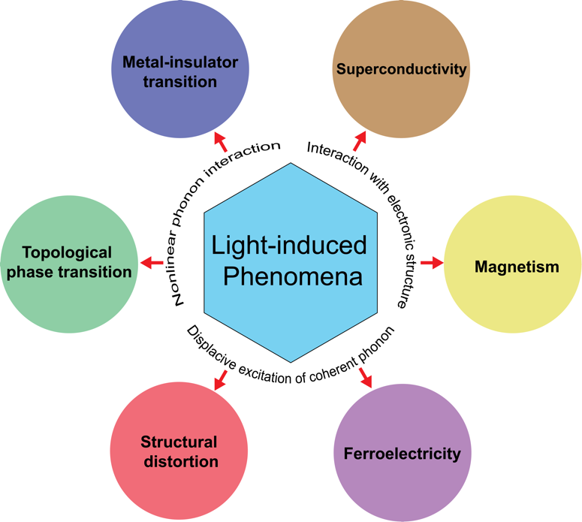
Figure 1. Light-induced phenomena and their possible microscopic mechanism.

References
[1] Sie, E. J. et al. An ultrafast symmetry switch in a Weyl semimetal. Nature 565, 61–66 (2019).
[2] Vaswani, C. et al. Light-Driven Raman Coherence as a Nonthermal Route to Ultrafast Topology Switching in a Dirac Semimetal. Phys Rev X 10, 021013 (2020).
[3] Guan, M.-X., Wang, E., You, P.-W., Sun, J.-T. & Meng, S. Manipulating Weyl quasiparticles by orbital-selective photoexcitation in WTe2. Nat Commun 12, 1885 (2021).
[4] Nova, T. F., Disa, A. S., Fechner, M. & Cavalleri, A. Metastable ferroelectricity in optically strained SrTiO3. Science 364, 1075–1079 (2019).
[5] Li, X. et al. Terahertz field–induced ferroelectricity in quantum paraelectric SrTiO3. Science 364, 1079–1082 (2019).
[6] Shin, D. et al. Simulating Terahertz Field-Induced Ferroelectricity in Quantum Paraelectric SrTiO3. Phys Rev Lett 129, 167401 (2022).

